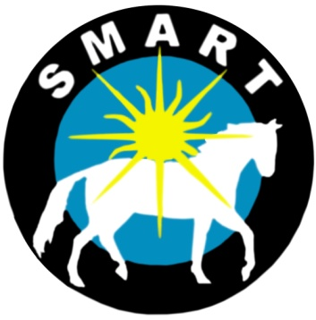
Release and Assumption of Risk Agreement for

Equine Assisted Activities – Field Trips

If Participant is under the age of 18, signature of Parent/Guardian is required.

Participant’s Name: __________________________________ would like to participate in the equine assisted activities provided by Sarasota Manatee Association for Riding Therapy. I acknowledge the risks and potential for risks of hands-on activities with horses. These activities with horses may include but are not limited to grooming, tacking, leading, riding, driving, bathing, feeding treats, clipping, catching, turning out, barn cleaning, and activities at liberty in round pen or paddocks, etc. However, I feel that the benefits to myself/my son/my daughter/my ward are greater than the risk assumed. I hereby, intending to be legally bound, for myself, my heirs and assigns, executors or administrators, waive and release forever all claims for damages against Sarasota Manatee Association for Riding Therapy, Inc. (SMART), it’s Board of Directors, Instructors, Therapists, Aides, Volunteers, Employees, and Sub Contractors for any and all injuries and/or losses I/my son/my daughter/my ward may sustain while participating in any activities provided by Sarasota Manatee Association for Riding Therapy, Inc. (SMART).

WARNING: Under Florida Law, an equine activity sponsor or equine professional is not liable for an injury to, or the death of, a participant in equine activities resulting from the inherent risks of equine activities.

Participant’s Name: ___________________________________ Date of Birth__________

Signature:____________________________________________ Date_________________

Parent / Legal Guardian (if Participant is under 18)

_____________________________________________________ Phone_____________________
Please print name of signature of above

_______________________________________________________________________________________________
Address City/State ZIP

Photo Release - please check one below:

I Do ________ or I Do Not _________

Consent to and authorize the use and reproduction by SMART (Sarasota Manatee Association for Riding Therapy) of any and all photographs and any other audio/visual materials taken of me for promotional material, educational activities, exhibitions or for any other use for the benefit of the program.

Signature: _____________________________________________ Date: _________
Parent / Legal Guardian if Participant is under 18

EMAIL Address: _______________________________________________________

